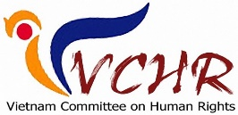
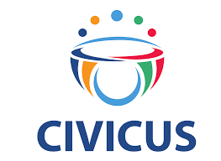



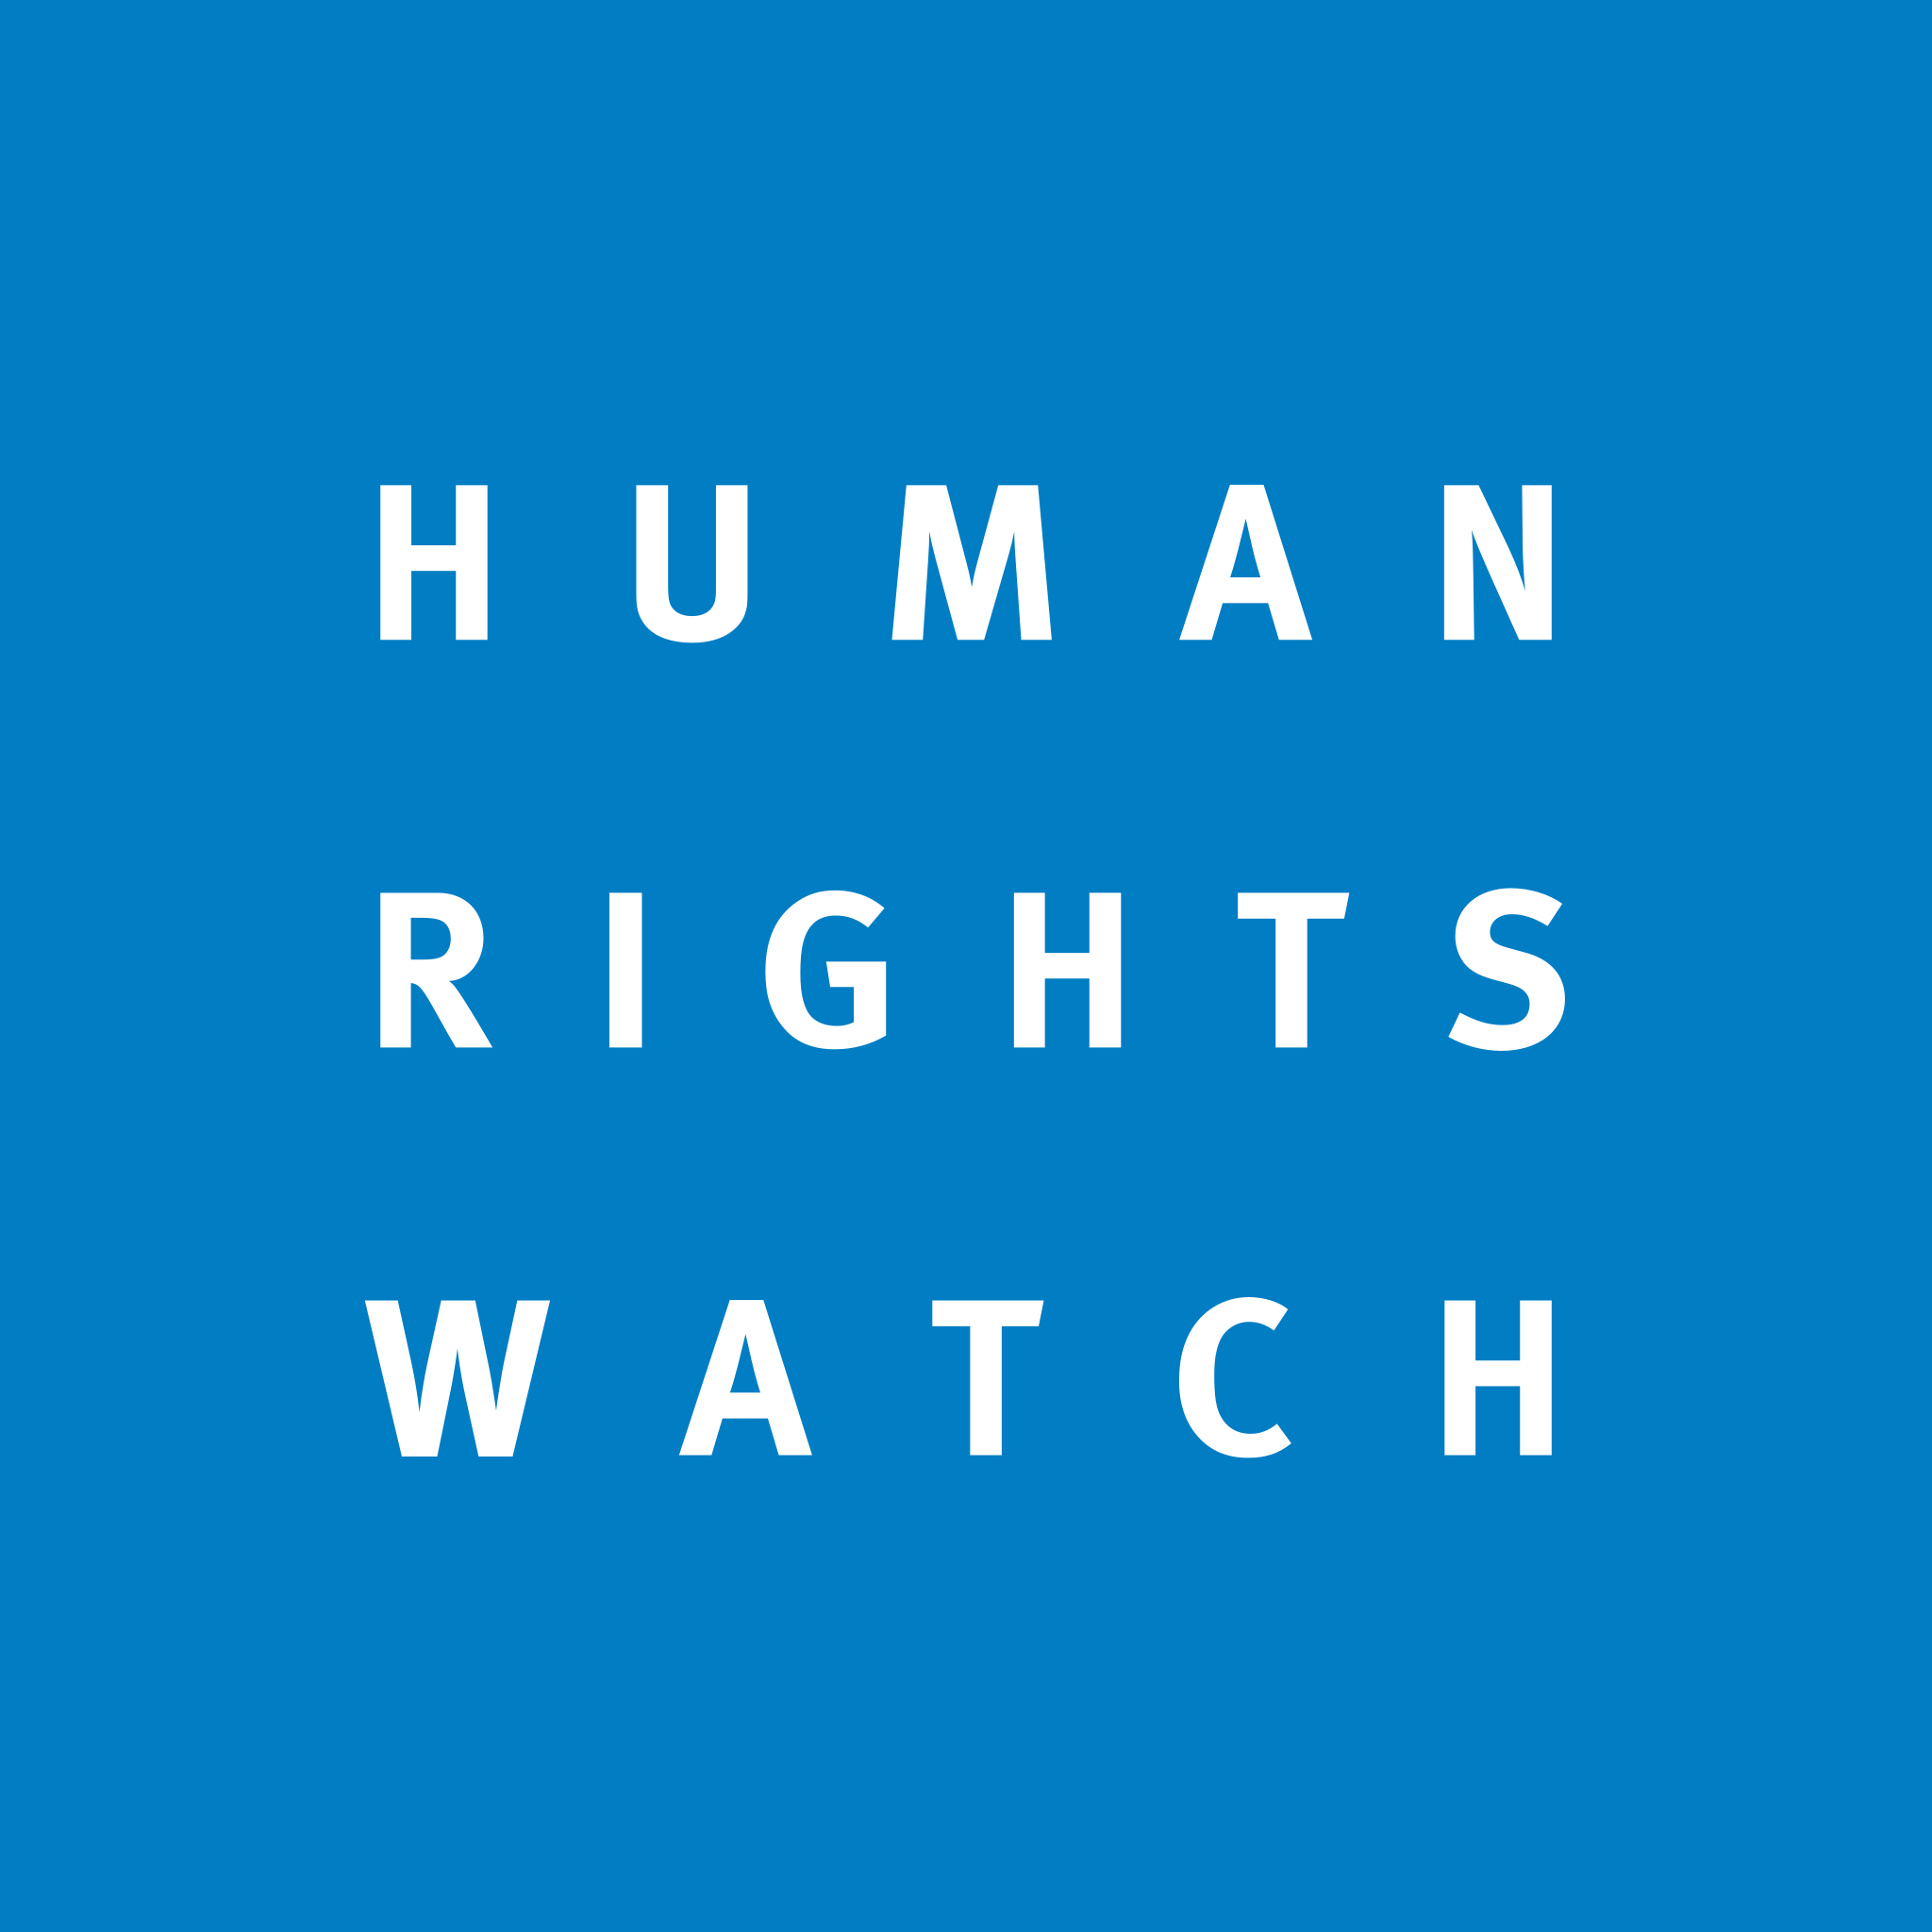


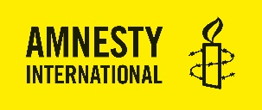






October 20, 2022

Mr. António Guterres
Secretary-General
United Nations
UN Headquarters, S-3800
New York, NY 10017

Re: October visit to Vietnam

Dear Secretary-General,

We are writing ahead of your visit to Vietnam later this week. You have emphasized the importance of combatting climate change, but this cannot be achieved without the role of environmental rights defenders. During your trip, we urge you to publicly call on the Vietnamese government to release the four environmental human rights defenders who were sentenced on trumped-up charges of “tax evasion” earlier this year. These political prisoners are emblematic victims of a new wave of repression in Vietnam which, through a combination of threats and judicial harassment, is threatening progress in combatting climate change, protecting human rights and achieving the Sustainable Development Goals.

The persecution of environmental defenders is only the tip of Vietnam’s broader crackdown on dissent. Organizations that monitor the situation have documented how Vietnam is currently holding hundreds of political prisoners. UN Human Rights Mechanisms have noted that once arrested, most of these people are prosecuted for vaguely worded national security crimes, subjected to prolonged periods of incommunicado detention, and denied access to legal counsel and family visitation, often while being subjected to willful neglect or mistreatment. These are people who have been persecuted for exercising their civil and political rights. These are people who should not be prosecuted, and should not be in prison.

The United Nations should urgently press the Vietnamese government to end its policies and practices that are subverting rather than supporting human rights, and emphasize that there can be no progress on climate change and development without an active civil society that can freely exercise their rights to freedom of expression, association, and assembly. We call on you to remind Vietnam that, as a newly elected member of the UN Human Rights Council, it has an obligation to uphold the highest human rights standards. Specifically, we urge you to:

- Publicly urge Vietnam to protect, promote and fulfill human rights obligations enshrined in the international human rights treaties signed and ratified by the government.
- Publicly urge Vietnam to cease criminalizing policy advocacy and the operation of advocacy coalitions by civil society. Specifically, Vietnam should implement the recommendations provided by the UN Human Rights Council’s independent experts in response to what they describe as Vietnam’s “undue restrictions on civil society…in violation of…international human rights law.”
- Publicly urge Vietnam to immediately and unconditionally release the four environmental defenders Nguy Thi Khanh, Mai Phan Loi, Bach Hung Duong, and Dang Dinh Bach.
- Publicly urge Vietnam to commit to stop arbitrarily arresting and detaining any additional environmental defenders, and all other human rights defenders, including journalists.
- Publicly urge Vietnam to fundamentally amend Decree 58/2022/ND-CP on international civil society groups working in Vietnam to ensure that those regulations fully comply with the International Covenant on Civil and Political Rights, to which Vietnam is a state party.
- Publicly urge Vietnam to clarify if, and in what circumstances, non-governmental development organisations are required to pay corporate tax. Specifically, the Vietnamese government should address ambiguity in and inconsistencies between the 2013 Science and Technology Law and the 2019 Law on Tax Administration in relation to the tax obligations of science and technology organisations. These regulations represent a contradictory policy framework that is open to politically motivated attacks on civil society organisations.

Finally, we believe that the UN system in Vietnam has an important role to play in this process. We urge you to call on the UN Resident Coordinator and UN agencies to publicly and pro-actively demand serious improvements to the government’s atrocious human rights record and to start holding it to account. The best way that the UN can do this is by making itself more accountable to Vietnamese civil society.

Sincerely,

Access Now
Amnesty International
Asia Democracy Network (ADN)
Asian Forum for Human Rights and Development (FORUM-ASIA)
ARTICLE 19
CIVICUS
Defend the Defenders
FIDH – International Federation for Human Rights
Frontline Defenders
Human Rights Watch
International Service for Human Rights (ISHR)
Legal Initiative for Vietnam
The 88 Project
Safeguard Defenders
Quê Me: Vietnam Committee on Human Rights

For example, Article 143.2 (“Tax evasion”) of the 2019 Law on Tax Administration stipulates: “Failure to record the revenues relevant to calculation of tax payable in the accounting books.” Similarly, Article 200.1.b (“Tax evasion”) of the 2015 Criminal Code stipulates: “Failure to record revenues related to the determination of tax payable in accounting books.” However, Article 4.7 of the 2008 Law on Corporate Income Tax, describes “Tax-exempt incomes” as “received financial supports used for educational, scientific research, cultural, artistic, charitable, humanitarian and other social activities in Vietnam.” Similarly, Decree 218 (218/2013/NĐ-CP), providing guidance on implementation of Law on Corporate Income Tax, stipulates that only organisations that improperly use financial aid are subject to corporate income tax.

